H.T No
Regulations:
A19

Sreenidhi Institute of Science and Technology
(An Autonomous Institution)
Code No:7Z338 Date: 03-Mar-2021 (FN)

MBA II-Year I- Semester External Examination, Feb/March - 2021 (Regular)
QUANTITATIVE APTITUDE AND LOGICAL REASONING

Time: 3 Hours Max.Marks:70

Note: a) No additional answer sheets will be provided.
b) All sub-parts of a question must be answered at one place only, otherwise it will not be valued.
c) Missing data can be assumed suitably.

ANSWER ANY 5 OUT OF 8 QUESTIONS. EACH QUESTION CARRIES 14 MARKS.

Bloom's Cognitive Levels of Learning (BCLL)

Remember | L1 | Apply | L3 | Evaluate | L5
Understand | L2 | Analyze | L4 | Create | L6

 |  |  | BCLL | CO(s) | Marks
1. | a) | Prashant Arora has three children – Sangeetha, Vimal and Ashish. Ashish married monika, the eldest daughter of Mr. Roy. The Roys married their youngest daughter to the eldest son of Mr. Sharma, and then had two children named Amit and Shashi. The Roys have two more children, Roshan and Vandana, both elder to veena. Sameer and Ajay are sons of Ashish. Rashmi is the daughter of Amit.  - What is the surname of Rashmi?  - How is Sameer related to Monika’s father?  - What is the surname of Sameer?  - How is Mrs. Roy is related to Ashish?  - Who is Prashant to Ajay? | L4 | CO1 | [7M]
 | b) | The digits 0 to 9 are coded as shown below along with exceptions I and II:  Exception I: If a number begins and ends with a a non-zero odd digit, then the first and the last digits are to be coded as Y and # respectively.  Exception II:If a number begins and ends with an even digit (including zero), then the first, and last digits are to be coded as & and X respectively.  - What is the code for 764981?  - What does MHLEK% represent?  - What does R%LAK@ represent?  - What will be the code for 173548?  - What is the code for 92583? | L5 | CO1 | [7M]
  digit | 3 | 8 | 0 | 7 | 4 | 6 | 9 | 2 | 5 | 1
  code | H | $ | R | A | M | % | L | K | E | @
2. | a) | Directions: Each of the following problems has a question and two statements which are labeled (1) and (2). Use that data together to decide whether the statements are sufficient to answer the questions. You mark  - If you can get answer from (1) alone but not from (2) alone;  - If you can get answer from (2) alone but not from (1) alone;  - If you can get answer from (1) and (2) together although neither statement by itself suffices:  - If (1) alone suffices and (2) alone suffices;  - If (1) and (2) are not sufficient and need more data.  - Is the integer “K” is odd or even?  - Square of K is odd  - 2K is even.  - What percentage is Y’s salary of X’s salary?  - X’s salary is 80% of Z’s salary.  - Y’s salary s 120% of Z’s salary  - Ram and Sita are standing together standing together on a sunny day. Ram’s shadow is 3 metres long. Sita ‘s shadow is 2.5 m long. How tall is sita?  - Ram is 2 m tall  - Ram is standing 0.75 m away from Sita. | L5 | CO2 | [7M]
 | b) | Depict this scene with a Ven diagram.  i) In a dinner party both fish and meat were served. Some took only fish and some only meat. There were some vegetarians who did not accept either. The rest accepted both fish and meat.  ii) College, students, teachers | L4 | CO2 | [7M]
3. | a) | i) How many times is the HCF of 48, 36, 72 and 24 contained in their LCM?  ii) Find the least multiple of 11 which, when divided by 8, 12 and 16 leaves 3 as remainder. | L3 | CO3 | [7M]
 | b) | - The average of 11 results is 50. If the average of first six results is 49 and that of last six is 52, find the sixth result.  - A train travels from A to B at the rate of 20 Km/hr and from B to A at the rate of 30Km/hr. What is the average rate for the whole journey? | L3 | CO3 | [7M]
4. | a) | - Divide Rs. 625 among A, B and C such that A gets 2/9 of B’s share and C gets ¾ of A’s share.  - Find the value of X in the following proportions:  5 : 15 =2 : X ; 75 : 3 = X : 9 | L4 | CO4 | [7M]
 | b) | A,B and C are partners. A receives 2/5 of the profit and B and C share the remaining profit equally. A’s income is increased by Rs. 220 when the prifit rises from 8% to 10%. Find the capitals invested by A, B and C. | L4 | CO4 | [7M]
5. | a) | - Find the difference between simple and the compound interests on Rs. 1250 for 2 yrs at 4% /annum.  - In what time will Rs. 8500 amount to Rs. 15767.50 at 4.5 percent per annum? | L3 | CO5 | [7M]
 | b) | A sum is invested at compound interest payable annually. The interest in two successive years was Rs. 225 and Rs. 236.25. Find the rate of interest and principal. | L3 | CO5 | [7M]
6. | a) | The questions refer to the following pie chart showing the expenditure distribution of a certain family. The family spends Rs. 6500/month.  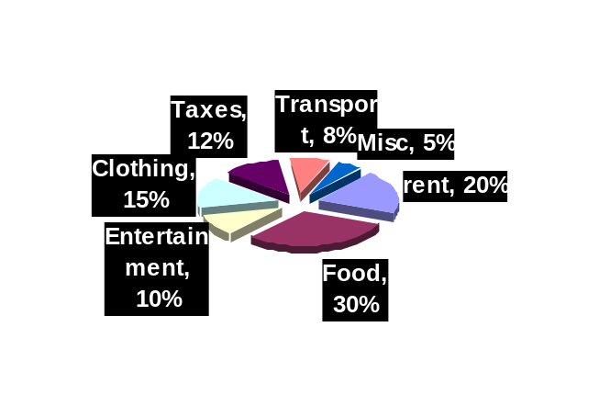  - How much they spends on food/month?  - How much are for annual taxes?  - How many degrees should there be in the central angle showing clothing, taxes and transportation combined?  - How much more money/month is spent on food compared to rent?  - If the expenditure is raised to Rs. 8000/m and distribution remains same, then how much will be monthly expenses on both entertainment and transport? | L5 | CO6 | [7M]
 | b) | Find the distance between the two parallel sides of a trapezium if the area of the trapezium is 250sq.m. and the two parallel sides are equal to 15m. 10 m respectively. | L4 | CO6 | [7M]
7. | a) | A family has a man, his wife, their four sons and their wives. The family of every son also has 3 sons and a daughter. Find out the total number of male members in the whole family. | L4 | CO1 | [5M]
 | b) | Draw ven diagrams for the following:  - Sun, Planets, Earth  - Dog, Animal, Pet  - Atmosphere, Hydrogen, Oxygen | L3 | CO2 | [5M]
 | c) | i). The LCM of two numbers is 2310 and their HCF is 30. If one of the numbers is 7x30, find the other number.  ii) HCF and LCM of 4/5, 5/6 and 7/15 | L3 | CO3 | [4M]
8. | a) | - The fourth proportional to 25, 15 and 40 is ?  - A, with Rs 1500, B with Rs. 2000 as share of capital. After 4 months is they admit C , who came with Rs. 2250. If B withdraws his contribution after 9 months, how would they share a profit of Rs. 900 at the end of the year? | L4 | CO4 | [5M]
 | b) | Find the Compound interest on Rs. 10000 in 9 months at 4% interest payable quarterly. | L3 | CO5 | [5M]
 | c) | How many paving stones each measuring 2.5 m x 2 m are required to pave a rectangular courtyard 30 m long and 16.5 m wide? | L3 | CO6 | [4M]

-- 00 -- 00 –

